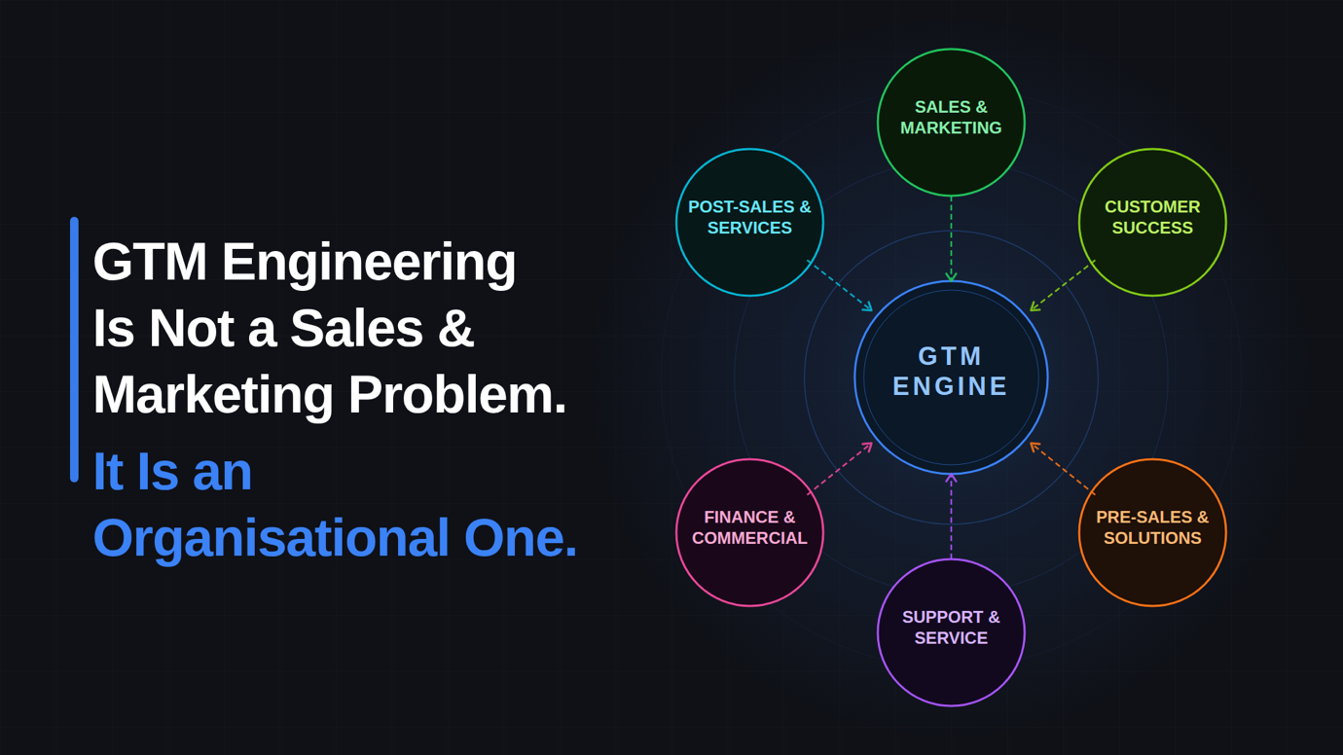

GTM Engineering Is Not a Sales and Marketing Problem. It Is an Organisational One.
Why the CRO and CMO alone cannot build the revenue machine B2B demands — and how to build it in phases that actually work
__________________________________________________________________________________________________
Every few years, B2B revenue leadership latches onto a discipline that promises to fix what headcount and budget alone cannot. GTM Engineering is that discipline today. And like most genuinely important ideas, it is already being misunderstood.
The prevailing framing positions GTM Engineering as the evolved intersection of sales operations, marketing technology, and growth automation. CROs and CMOs are told to align, invest in the stack, hire a GTM Engineer, and watch pipeline improve.
That framing is not wrong. It is just dangerously incomplete.
Go-To-Market does not end at the sales close. It lives in every interaction your organisation has with a customer or prospect — from the first impression to the renewal conversation, from the support ticket to the executive business review. If your GTM Engineering only covers the first two acts of that story, you are engineering half a system and calling it a solution.
The more accurate, and far more powerful, definition is this:
GTM Engineering is the design and operation of intelligent systems that coordinate every customer-facing function — across the full customer lifecycle — to create a coherent, signal-driven, and continuously improving revenue experience.
That is a materially different ambition. And it requires a materially different conversation — including an honest one about how to build it without breaking the organisation in the process.

The Functions That Belong Inside GTM Engineering:
Before addressing how to build it, it is worth being specific about what the conventional Sales-and-Marketing framing leaves on the table.
Customer Success holds the richest signal asset in the business — product usage, NPS trajectories, churn indicators, expansion readiness. In most organisations none of it feeds the GTM motion. Marketing acquires customers without knowing what makes them succeed. Sales chases logos that will churn in year two. That is a GTM Engineering failure, not a CS one.
Pre-Sales and Solutions Engineering uncovers the real buying triggers — technical anxieties, integration concerns, internal political dynamics — that shift deal trajectories. That intelligence typically evaporates at close, never reaching Marketing to sharpen positioning or CS to prepare for onboarding.
Post-Sales and Professional Services sees what breaks down after contract signature — the gaps between what was sold and what was delivered, the use cases that were underserved. Every friction point is a product insight, a positioning risk, and a competitor's next case study if they are paying attention and you are not.
Customer Support and Service is frequently the highest-frequency customer touchpoint in the business and the most structurally disconnected from GTM strategy. Support ticket sentiment, escalation patterns, and recurring questions are real-time market intelligence sitting unused in most organisations.
Finance and Commercial teams determine whether commercially-won deals actually close. An eleven-week procurement cycle, a four-approval contracting workflow, or an inflexible pricing structure are GTM problems wearing finance costumes — and they belong inside the GTM Engineering conversation.
The full picture is an organisation where every customer-facing function contributes signal, and every signal improves the next interaction. That is the destination. The question is how to get there without attempting everything at once.
Big Bang vs. Phased: The Honest Answer
Most GTM Engineering transformations that fail do so not because the vision was wrong but because the approach was.
Big Bang — attempting to connect all functions simultaneously, stand up the full data infrastructure at once, and align Sales, Marketing, CS, Finance, and Product around a shared GTM architecture in a single programme — collapses under its own weight. It demands cross-functional alignment that has never existed before. It requires infrastructure investment before anyone sees results, which rapidly exhausts executive patience. It creates simultaneous change fatigue across every revenue-touching team. And it almost always stalls at the integration layer — the hardest, least glamorous part of the build — before a single business outcome is visible.
Phased is the only approach that works in practice. Not because ambition should be limited, but because each phase produces visible results that fund the next, builds organisational confidence, and creates the data infrastructure that later phases depend on. The full vision remains intact. The execution is sequenced to survive contact with reality.
The sequencing of which function you start with matters as much as the decision to go phased. The wrong starting point wastes months building a foundation nobody connects to.

The Four Phases of GTM Engineering: A Practical Roadmap
Phase One: Sales and Marketing — Build the Foundation and Win Quickly
Start here. Not because Sales and Marketing are the most important functions in the GTM Engineering vision — we have established they are not — but because the tooling is most mature, the data is most accessible, the mandate is least contested, and the return on investment is fastest to demonstrate. A visible win in Phase One is what earns the organisational credibility and budget to fund everything that follows.
The goal in this phase is to move from a campaign-driven GTM motion to a signal-driven one. That means building the data foundation — account enrichment, firmographic and technographic intelligence, third-party intent data — so that outreach is triggered by real buying behaviour rather than arbitrary sequence steps or calendar intervals. It means connecting the CRM, the marketing automation platform, and the sales engagement platform so they share data bidirectionally and in real time. And it means deploying AI across the Sales-Marketing motion — for account research, call preparation, personalised outreach, and pipeline forecasting — on top of clean, connected data.
The metrics that define success here are straightforward: improved pipeline quality, higher conversion rates from MQL to opportunity, shorter sales cycles, and more accurate revenue forecasting. These are numbers every CRO and CMO owns and understands. Demonstrate them clearly and the cross-functional conversation that Phase Two requires becomes significantly easier.
AI plays an important role in this phase, but with a critical caveat. AI-generated outreach personalisation is no longer a differentiator — every competitor has access to the same tools. The advantage comes from the quality of the signal that triggers the AI, and the quality of the data that informs it. Intent data, technographic fit, and real account intelligence fed into AI workflows will outperform generic AI personalisation every time. Build for signal quality, not output volume.
Phase Two: Customer Success — Connect the Richest Signal in the Business
With the Sales-Marketing foundation established and producing results, Phase Two extends the GTM Engineering architecture into Customer Success — the single highest-leverage expansion available.
CS holds data that transforms the GTM motion in ways the Sales-Marketing layer alone never can. Health scores built from product usage, support history, engagement patterns, and commercial signals become the organisation's early warning system for both churn risk and expansion opportunity. When that intelligence flows back into the CRM in real time — rather than sitting in a CS dashboard until a quarterly business review — the entire revenue motion shifts from reactive to proactive.
The practical connection points in this phase are specific. Health score deterioration should automatically trigger a coordinated response: a task in the CRM, an alert to the account owner, and a re-engagement workflow — without a human initiating each step. Expansion signals — deep product adoption, positive NPS movement, increasing user counts — should automatically surface to the relevant AE as a prioritised opportunity. Renewal risk identified ninety days out should trigger a structured save play, not a panicked call three weeks before contract end.
There is a strategic benefit here that extends beyond retention. The richest Ideal Customer Profile data in the business lives in CS — not at the top of the funnel. Which customers renew, expand, and advocate. Which ones churn and why. Which onboarding paths correlate with long-term success. Connecting this data back into the Phase One architecture means that marketing campaigns, sales targeting, and ICP definitions are now informed by customer reality rather than acquisition assumptions. That is a qualitative shift in how the whole GTM motion operates.
Phase Two also delivers the business case that brings the CCO and CFO genuinely into the GTM Engineering conversation — because the metrics it moves are retention rate, net revenue retention, and expansion revenue, which are the numbers that increasingly define B2B enterprise value.
Phase Three: Pre-Sales, Support, and the Intelligence Loop
By Phase Three, the data infrastructure built in the first two phases is capable of absorbing new signal sources without rebuilding from scratch. The focus now is closing the intelligence loops that most organisations leave permanently open.
Conversation intelligence from Pre-Sales and Solutions Engineering is the first loop to close. Every discovery call, every technical deep-dive, every objection handled during proof of concept contains insight that should inform marketing positioning, sales playbooks, and CS onboarding. Deploying conversation intelligence tools across Pre-Sales — and routing the structured output back into the CRM and marketing systems — means that competitive objections surface in real time, common technical blockers sharpen the product roadmap, and the intelligence gathered in the hardest conversations in the sales process stops evaporating at close.
The Support and Service loop is the second. Support ticket categorisation, sentiment analysis, and escalation pattern detection — when connected to account health scoring in the CS platform and flagged in the CRM — complete the picture of account relationships that no single function has visibility of alone. An account with three open escalations, a declining health score, and an AE who has not engaged in sixty days is a churn risk that a connected GTM system surfaces automatically. A disconnected one discovers it on the renewal call.
AI is particularly powerful in this phase. Natural language processing applied to support queues and call transcripts at scale surfaces patterns that no human team reviewing individual tickets would detect — and routes them as structured intelligence to the functions that can act on them.
Phase Four: Finance, Commercial, and the Complete Revenue System
The final phase brings the commercial and financial layer into the GTM Engineering architecture — and by this stage, the conversation with the CFO is significantly easier to have. The upstream GTM motion is clean, connected, and producing measurable results across acquisition, retention, and expansion. The bottleneck that is now visible — and increasingly painful — is the commercial journey from proposal to signature.
Contracting cycle time, pricing approval workflows, deal desk capacity, and commercial flexibility are not traditionally GTM concerns. But in complex B2B sales, they are deal killers. A connected GTM architecture that routes commercial friction points — long approval chains, pricing exceptions that require escalation, contract terms that slow legal review — back to Revenue Operations as structured data creates the evidence base for the process redesign that Finance and Legal have previously resisted.
The goal in this phase is not to turn Finance into a sales function. It is to make the commercial experience a deliberate part of the GTM design — one that is measured, optimised, and connected to the same revenue outcomes that Sales and Marketing are held accountable for.
By the end of Phase Four, the organisation has what most B2B companies describe as the goal but few ever reach: a single, intelligent, continuously learning revenue system where every customer-facing function contributes signal, and every signal improves the next interaction.
AI Across All Four Phases: The Accelerant With a Prerequisite
AI appears in every phase of this roadmap — but its role evolves as the architecture matures.
In Phase One, AI accelerates the Sales-Marketing motion through smarter prospecting, faster account research, and more accurate forecasting. In Phase Two, AI powers predictive health scoring and automated lifecycle triggers in CS. In Phase Three, AI processes conversation and support data at a scale that generates organisation-wide intelligence from previously unstructured sources. In Phase Four, AI identifies commercial friction patterns and models the revenue impact of process changes.
The consistent principle across all four phases: AI is infrastructure, not a campaign. The organisations extracting genuine competitive advantage from AI in GTM are not the ones running clever outreach sequences. They are the ones who built clean, connected, cross-functional data architecture first — and then deployed AI across it. The technology rewards the structural work. It does not substitute for it.
Who Owns This
A phased approach still requires clear ownership from day one — because without it, each phase becomes a standalone project rather than a connected programme.
The CRO holds overall accountability for the revenue outcomes each phase is designed to deliver. The CMO owns the demand and signal infrastructure that Phase One establishes. The CCO becomes a critical co-owner from Phase Two onwards. The CFO needs visibility from the start — even if their function is not directly engaged until Phase Four — because the data infrastructure investment requires financial commitment before the full return is visible.
Revenue Operations, elevated to span all customer-facing functions, is the engineering team that builds and maintains the architecture across all four phases. This is not a role that sits inside Sales. It is an organisational capability that sits across the entire revenue system.
The Organisation You Are Building Toward
The destination has not changed. The B2B organisations that will win the next decade are the ones that engineer their entire customer-facing operation as a single, intelligent, continuously learning system — where a prospect's first interaction informs the discovery conversation, the discovery conversation informs onboarding, onboarding informs the renewal strategy, and the renewal strategy feeds back into how the next customer is acquired.
That is not a vision. It is an engineering problem. And the phased approach described here is how organisations with real commercial pressures, finite budgets, and competing priorities actually solve it — without attempting everything at once and delivering nothing.
Start with Sales and Marketing. Win visibly. Connect CS. Close the intelligence loops. Bring Finance into the architecture. Each phase builds on the last. Each phase produces results that justify the next.

© 2026 Phoenix Forge Consulting. All rights reserved

